**MyHealthKeeper**



iOS Application User Guide

Gayatri Patel

Melissa Heredia

Gopika Menon

Thanjila Uddin

# Table of Contents

**Table of Contents**1

**Introduction**3

Download Application 3

New User 4

Registration 5

Login 6

Reset Password 6

Menu 8

Enter Medical Data 9

1. Personal Information 9

2. Enter List of Doctors 10

3. Enter List of Illnesses/Diseases 14

4. Enter List of Medication 15

5. Enter List of Surgeries 16

6. Enter List of Allergies 16

7. Enter List of Vaccines 18

8. Medical History 19

9. Insurance Information 20

10. Medical Summary 21

Upload Document 22

Set Reminder 24

View Reminders 25

Print 26

# Introduction

MyHealthKeeper will help users to keep track of their medical data such as their Personal Information, Medical Information which includes Doctor, Illness, Medication, Surgery, Allergy, Vaccine, Family Medical History and Additional Information; and Insurance Information. This Application also allows users to upload medical reports, and set appointment and monthly reminders. Finally, the user will be able to print and save their medical data/report as a PDF.

## Download Application

Download the MyHealthKeeper App from the App store. The MyHealthKeeper application icon is shown in *Figure 1.*

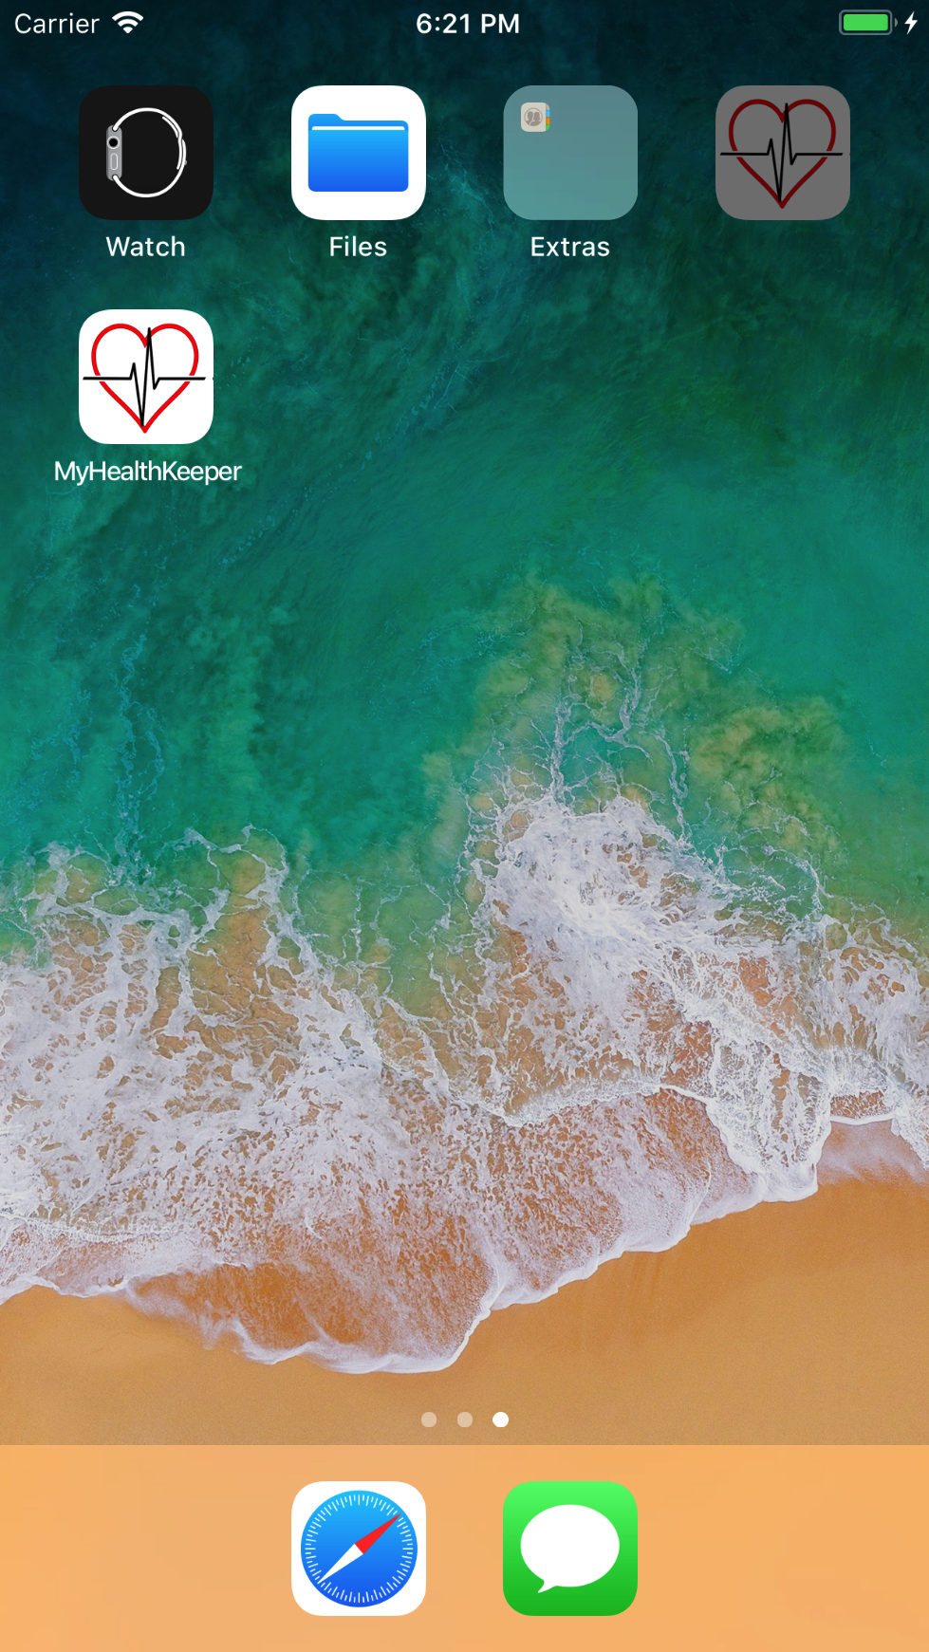

*Figure 1: MyHealthKeeper App Icon*

## New User

Open MyHealthKeeper once it has been downloaded on the iOS device. The launch screen will appear as shown in *Figure 2*. The **Sign In** screen will follow to either Sign In or Register a new account. To create a new account, tap on **Click to Register** as shown in *Figure 3.*

 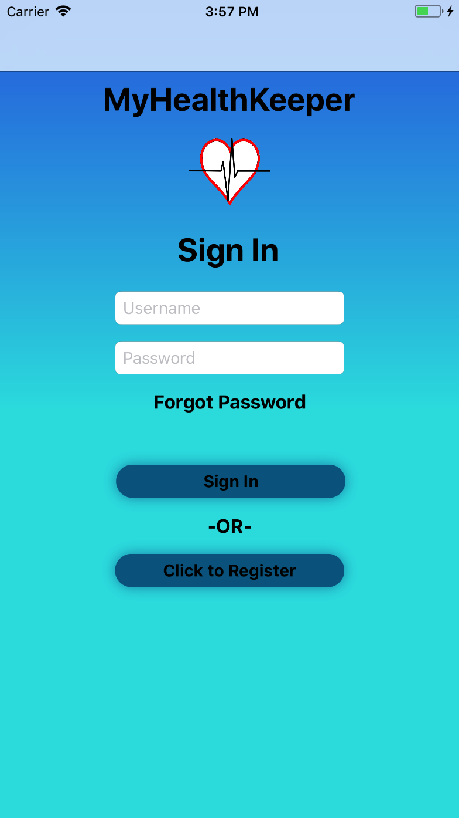

*Figure 2: Launch screen* *Figure 3: Sign In screen*

## Registration

To create an account, enter all required text fields as shown in *Figure 4,* then tap on the **Next Page** button. Set up three different security questions using the pickers on the bottom of the screen. Answer the security questions using the keyboard and tap on the **Finish & Sign In** button as shown in *Figure 5.*

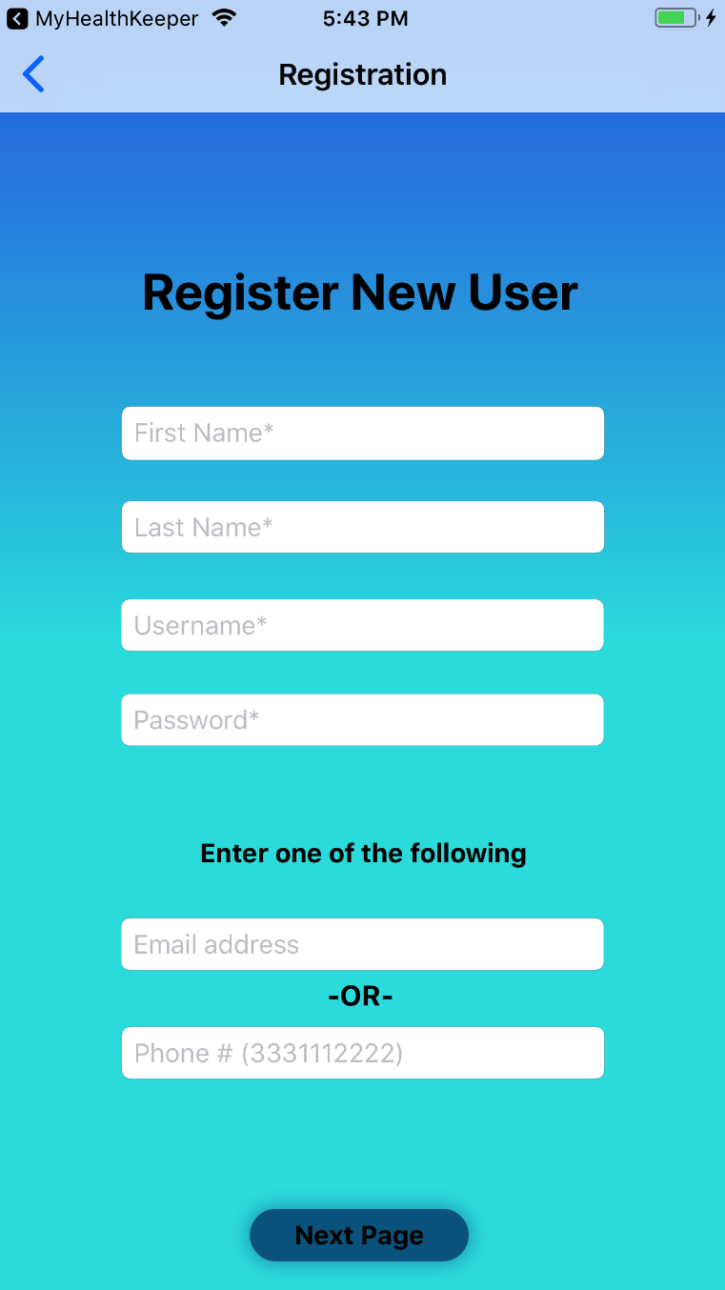 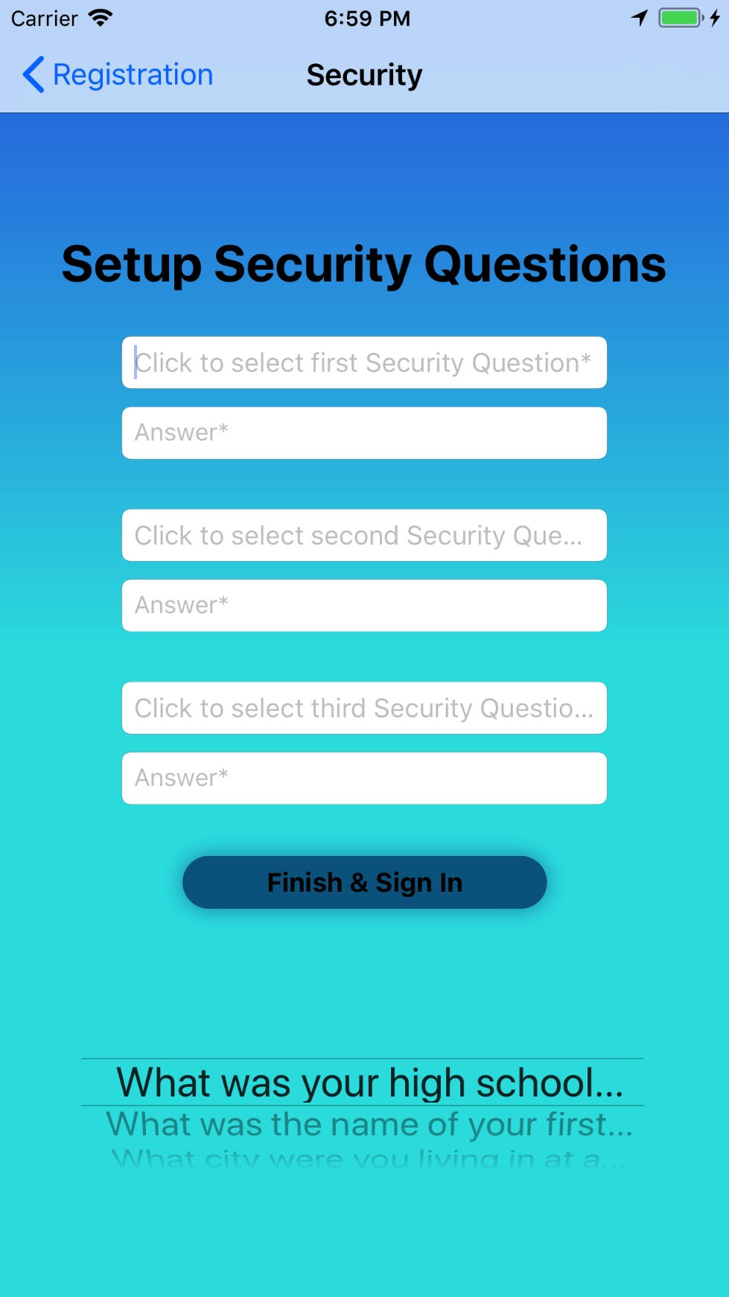

*Figure 4: Registration screen Figure 5: Security Question screen*

## Login

Enter the username and password that you registered with in the **Registration** section, and input the fields into the username and password fields in the **Sign In** screen, see *Figure 2.* Next, tap on the **Sign In** button.

## Reset Password

If you are a registered user and forgot your password you can reset your password by following the steps below:

1. Enter your username in the username text field on the **Sign In** screen (see *Figure 3*)
2. Tap on **Forgot Password** on the **Sign In** screen (see *Figure 3*).
3. Answer the Security questions as shown in *Figure 6.* Tap the **Submit** button.
4. Reset new password as shown in *Figure 7.*
5. Tap the **Submit New Password** button.
6. Login with your username and new password on the **Sign In** screen (see *Figure 3*)

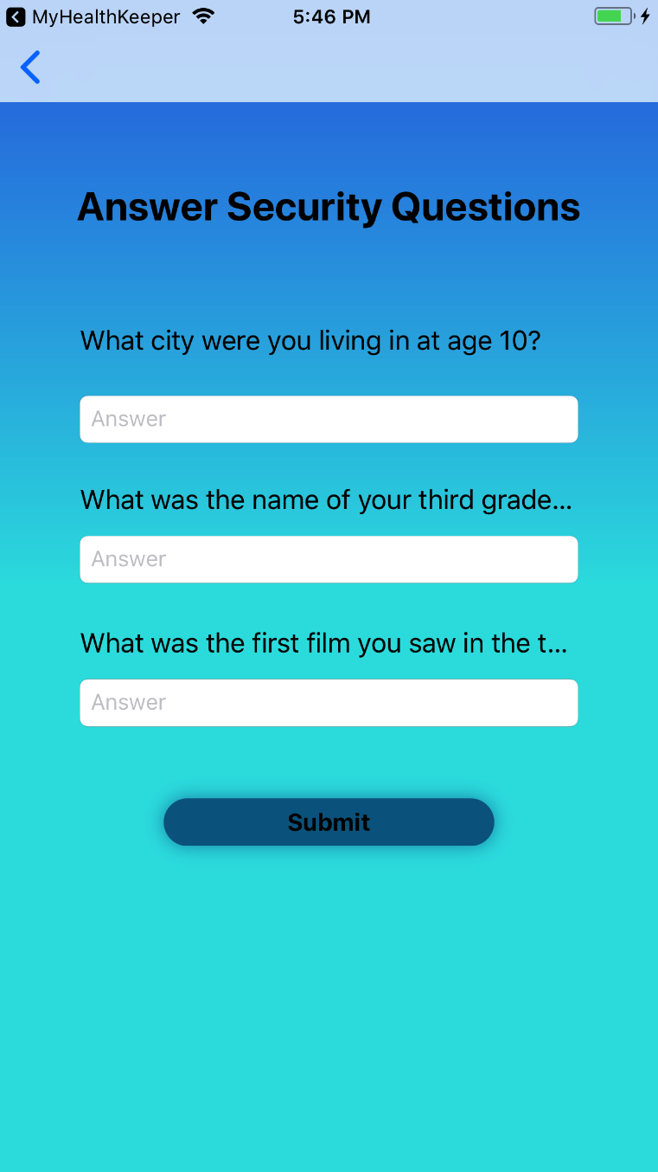 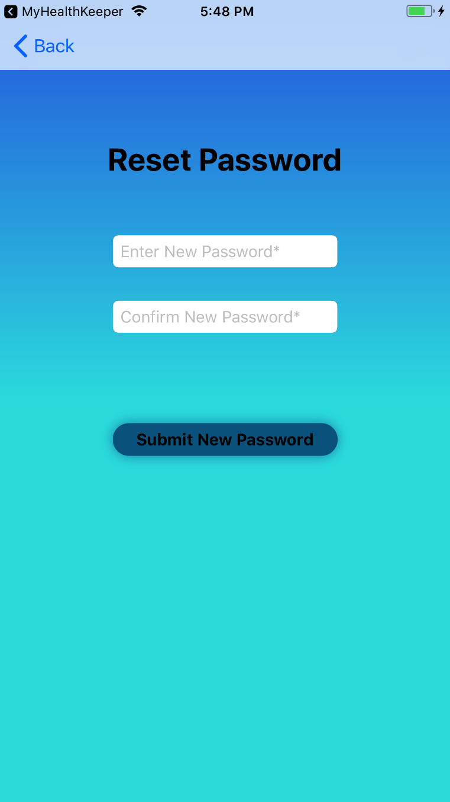

*Figure 6: Answer Security Questions Figure 7: Reset Password*

## MyHealthKeeper Home (Main) screen

The **Home (Main)** screen of MyHealthKeeper has three main functionalities: Enter Medical History, Upload Document, and Set Reminder as shown in *Figure 8*.

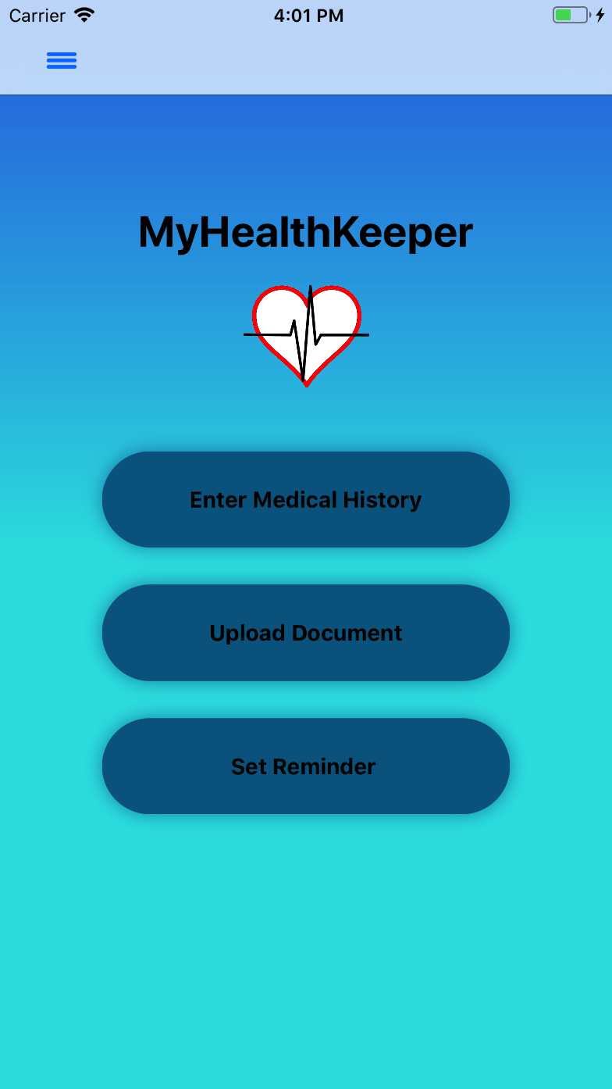

*Figure 8: Home (Main) screen*

## Menu

The Menu is located on the top left corner of every screen inside the MyHealthKeeper Application as shown in *Figure 9*. Tap on the **Menu icon** located in the top left corner of the screen, and the menu will slide in from the left side of the screen. Tap on any section in the Menu to navigate to any page in the app. Tap on the **Medical Data** button to expand the Medical pages as shown in *Figure 10.*

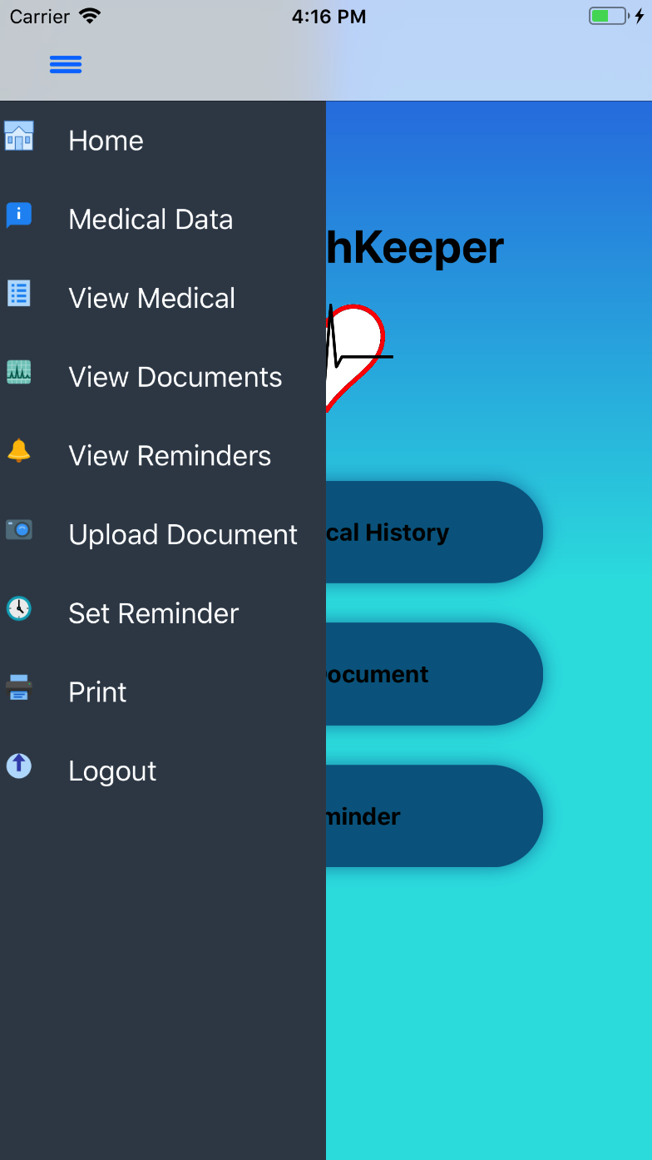 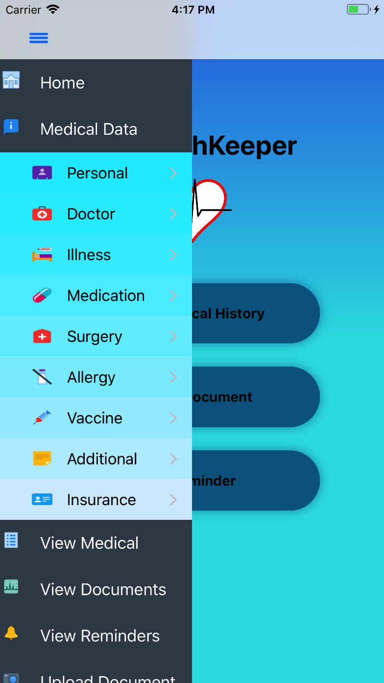

*Figure 9: Menu Figure 10: Expanded Menu*

## Enter Medical Data

### 1. Personal Information

Tap on the **Enter Medical History** button from the Main screen, see *Figure 8*.

1. Enter Personal Information in the required text fields.
   1. To enter your State, select it from the picker displayed below the text field.
2. Tap the **Save and Continue** button to save Personal Information as shown in *Figure 11*.

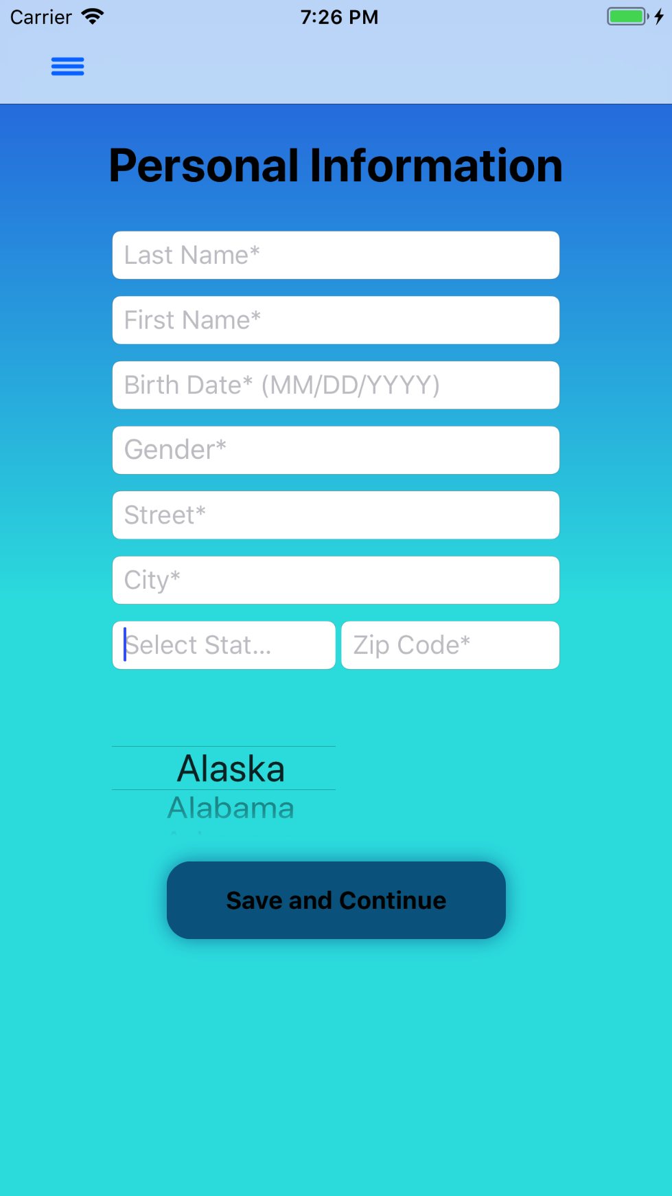

*Figure 11: Personal Information screen*

### 2. Enter List of Doctors

*\*Functionalities, with the exception of the phone call feature, stated in this section applies for all medical-related pages.*

*\*The Delete feature applies for all medical-related pages, Document Summary, and Reminder Summary.*

Tap on the **Save and Continue** button, shown on *Figure 11*, to be directed to the **Enter List of Doctors** screen. When directed to this screen, the required text field Name of the Doctor will be visible. To view the optional text fields, tap on the **blue arrow** next to the ‘Name of the Doctor’ text field. To add information for a Doctor, enter the Doctor Name, Specialty, Phone Number, and Address in the provided text fields, *see Figure 12.* Tap the **Add** button. This will display and save the information, *see Figure 13*.

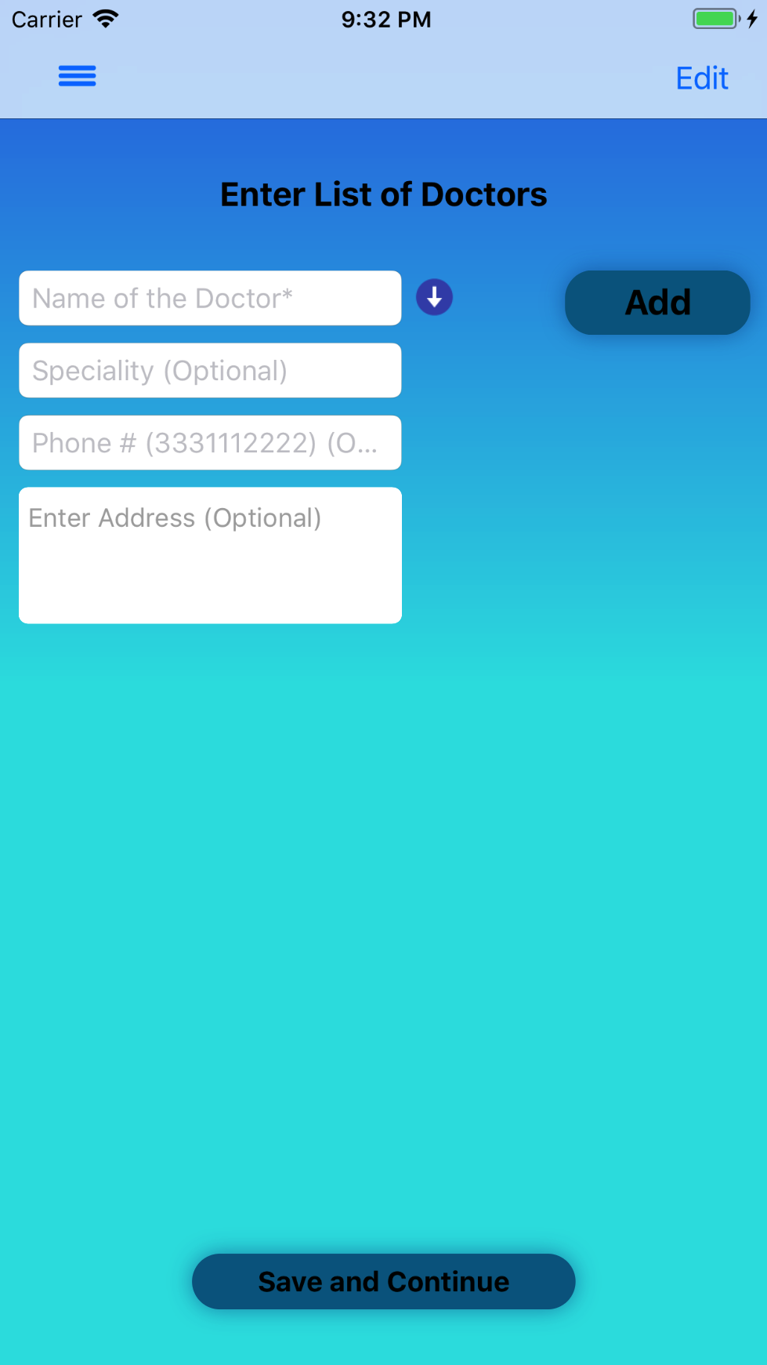 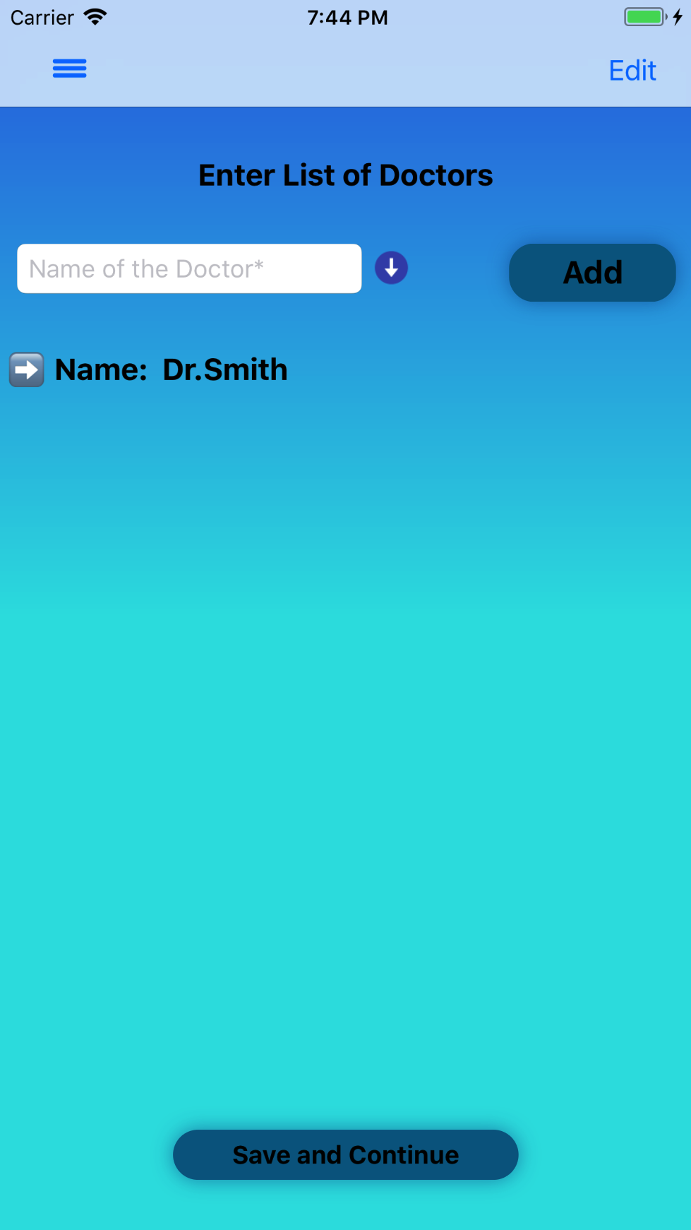

*Figure 12: Enter Doctor Info screen Figure 13: Enter List of Doctors screen*

By tapping on the **drop-down arrow** button next to the displayed Doctor Name, *see Figure 14*, the section holding the Doctor Name will expand, and display detailed information about the Doctor. Tapping on the phone number will allow the user to make a phone call, *see Figure 15.*

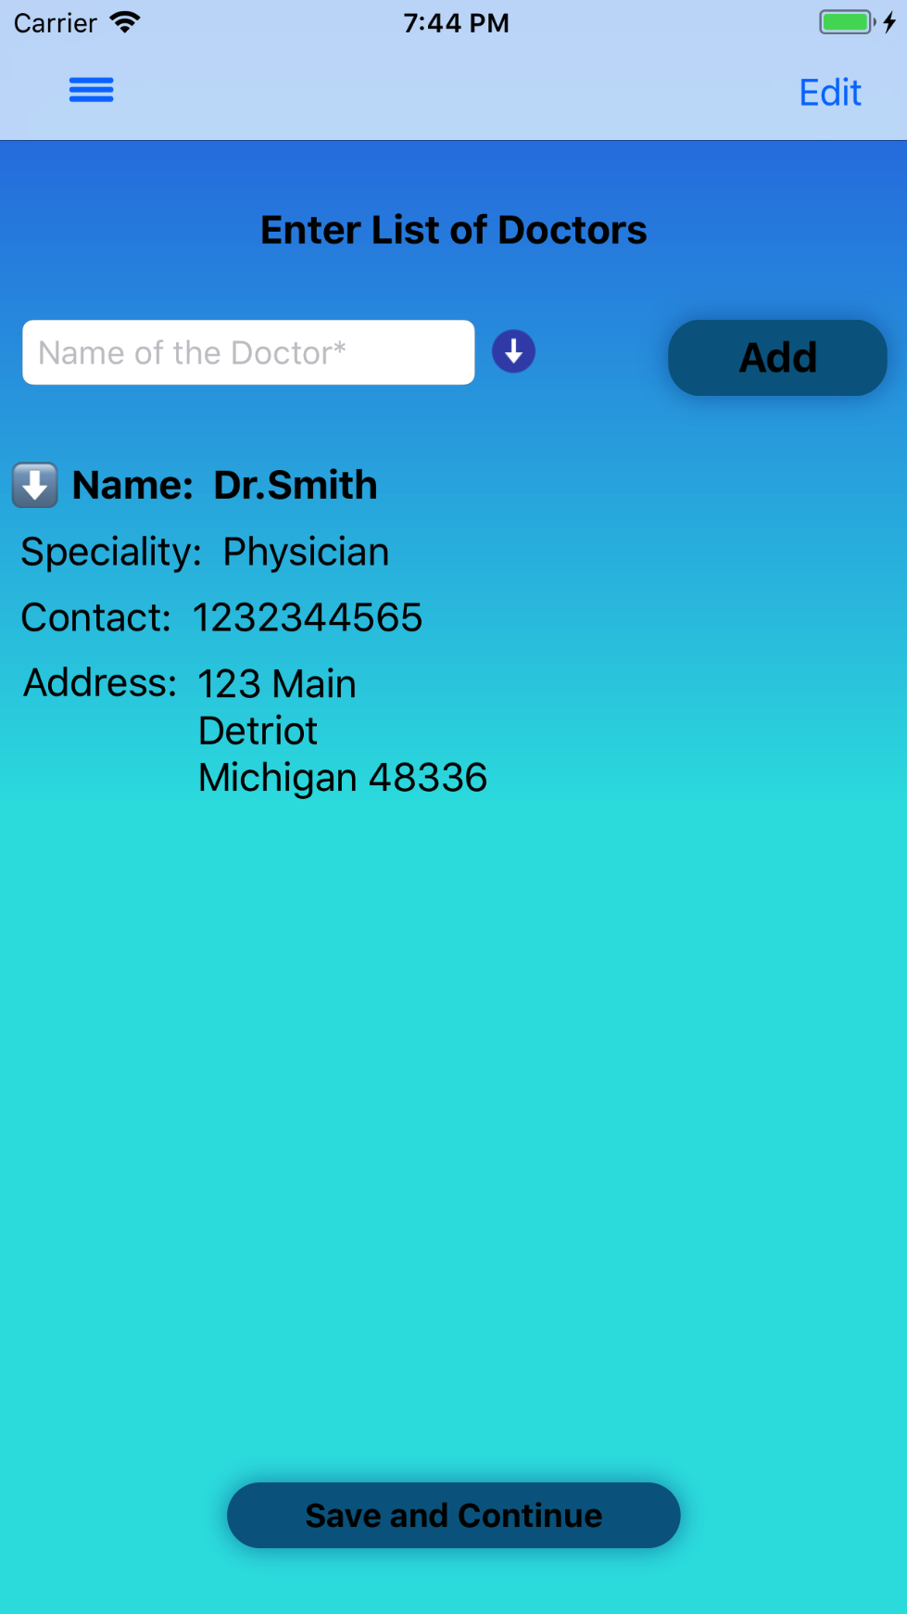 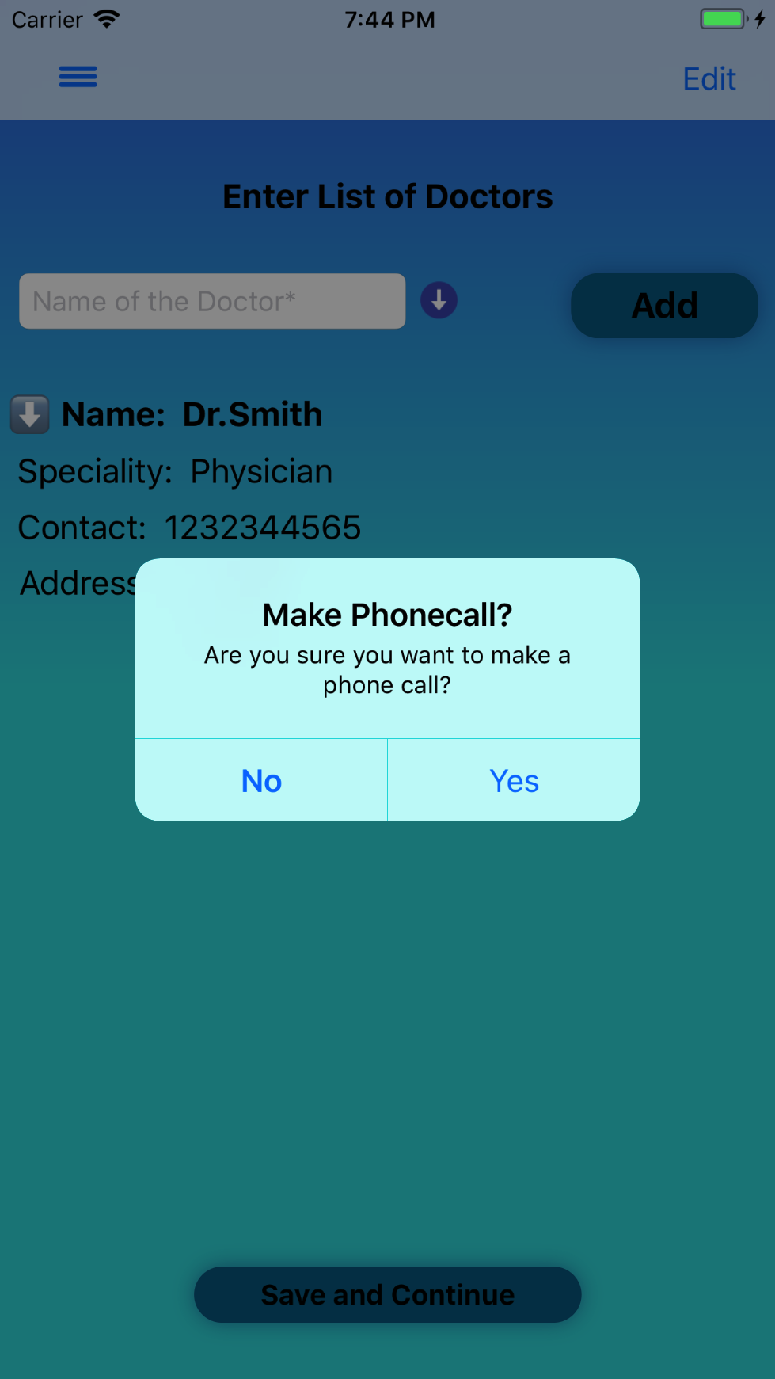

*Figure 14: Display Doctor Info screen Figure 15: Phone Call screen*

Tapping on the **Edit** button on the top right corner, *see Figure 13,* will bring up a red, circular icon to the left of the Doctor Name as shown in *Figure 16*. Tapping on the red icon will slide the cell to the left, and will bring up buttons to **Edit** or **Delete**, *see Figure 17.* If the gray **Edit** button is tapped, the **Edit** screen will appear, *see Figure 18.* To delete information, tap on the red **Delete** button to delete information.

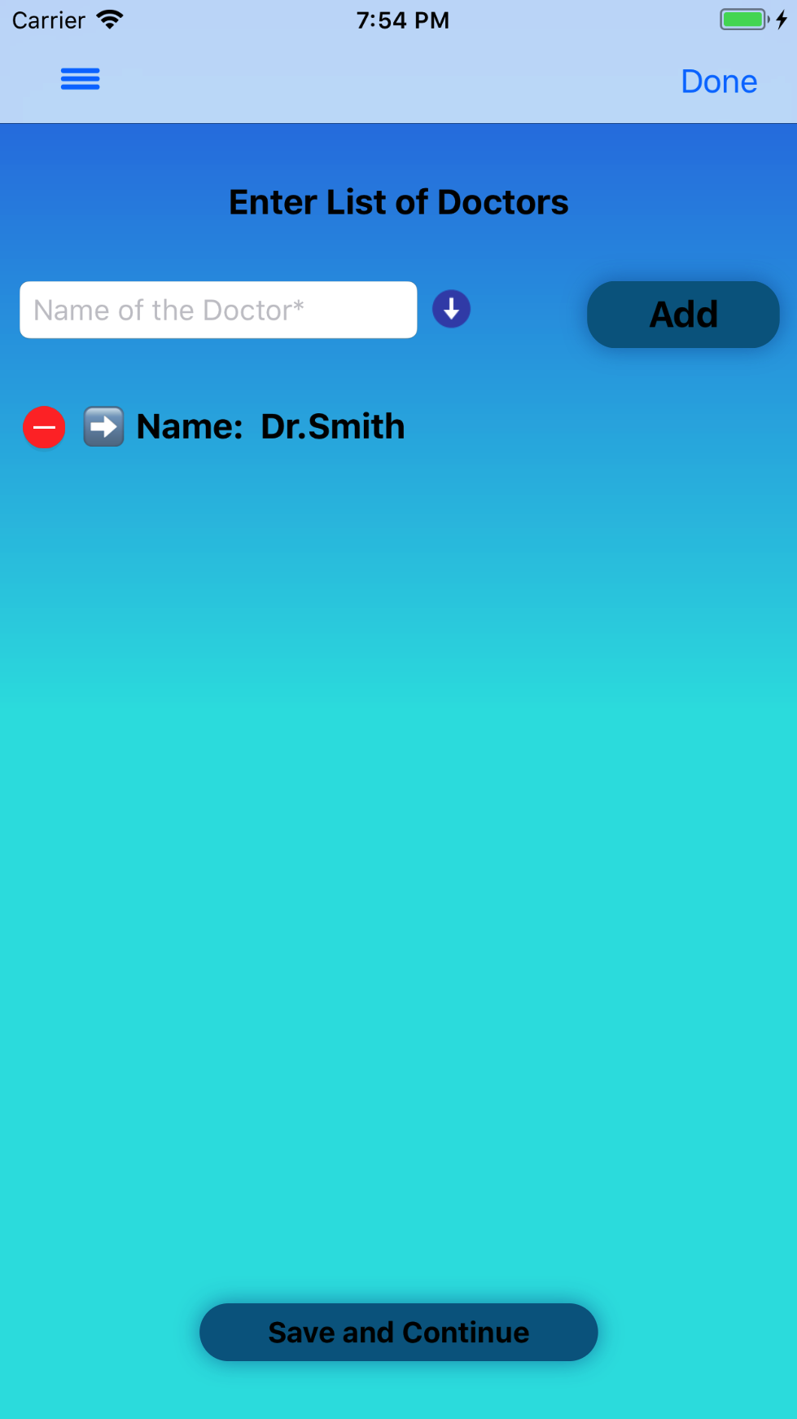 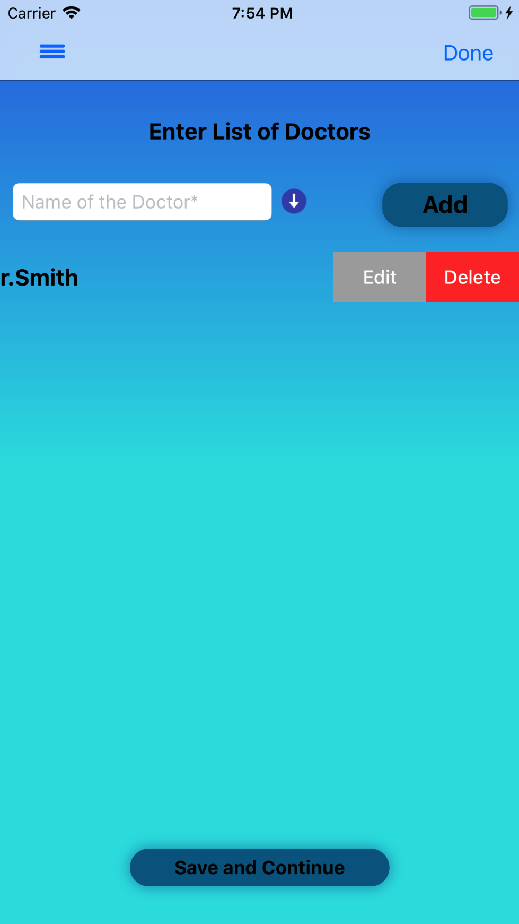

*Figure 16: Edit Figure 17: Edit/Delete Buttons*

The text fields will be populated with the information found in the row as shown in *Figure 18*. The information can be changed and updated by tapping the **Update** button. Edited information will be updated in the **List of Doctors** screen as shown in *Figure 19*.

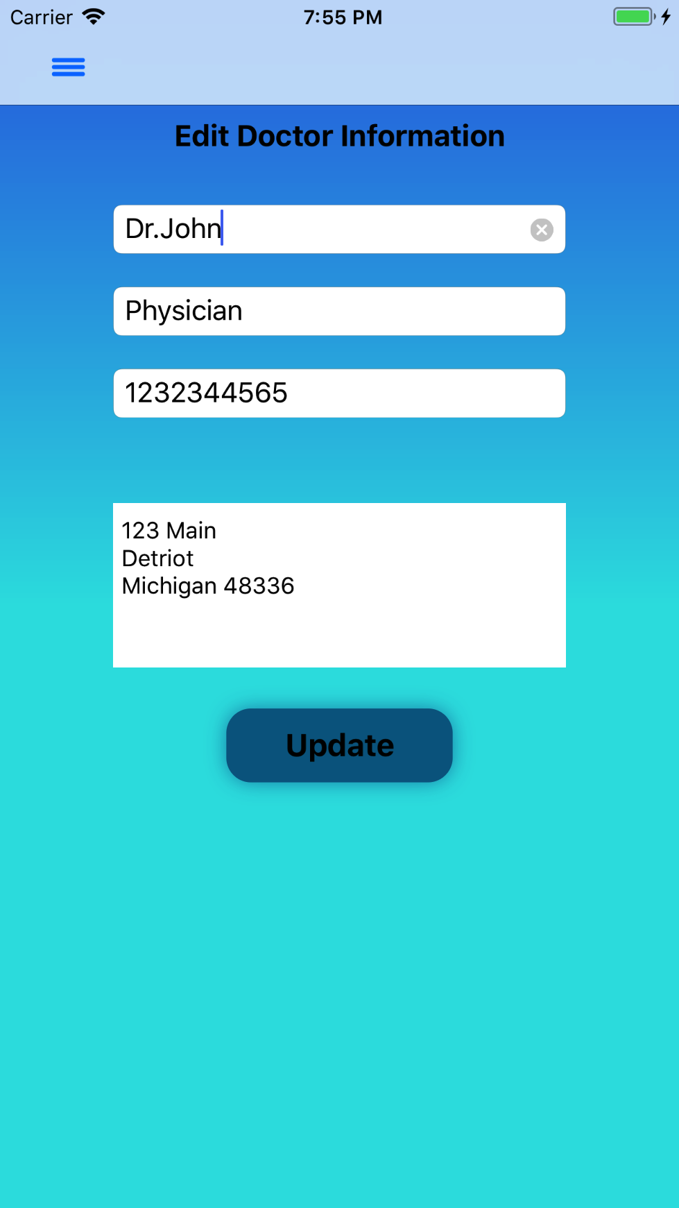 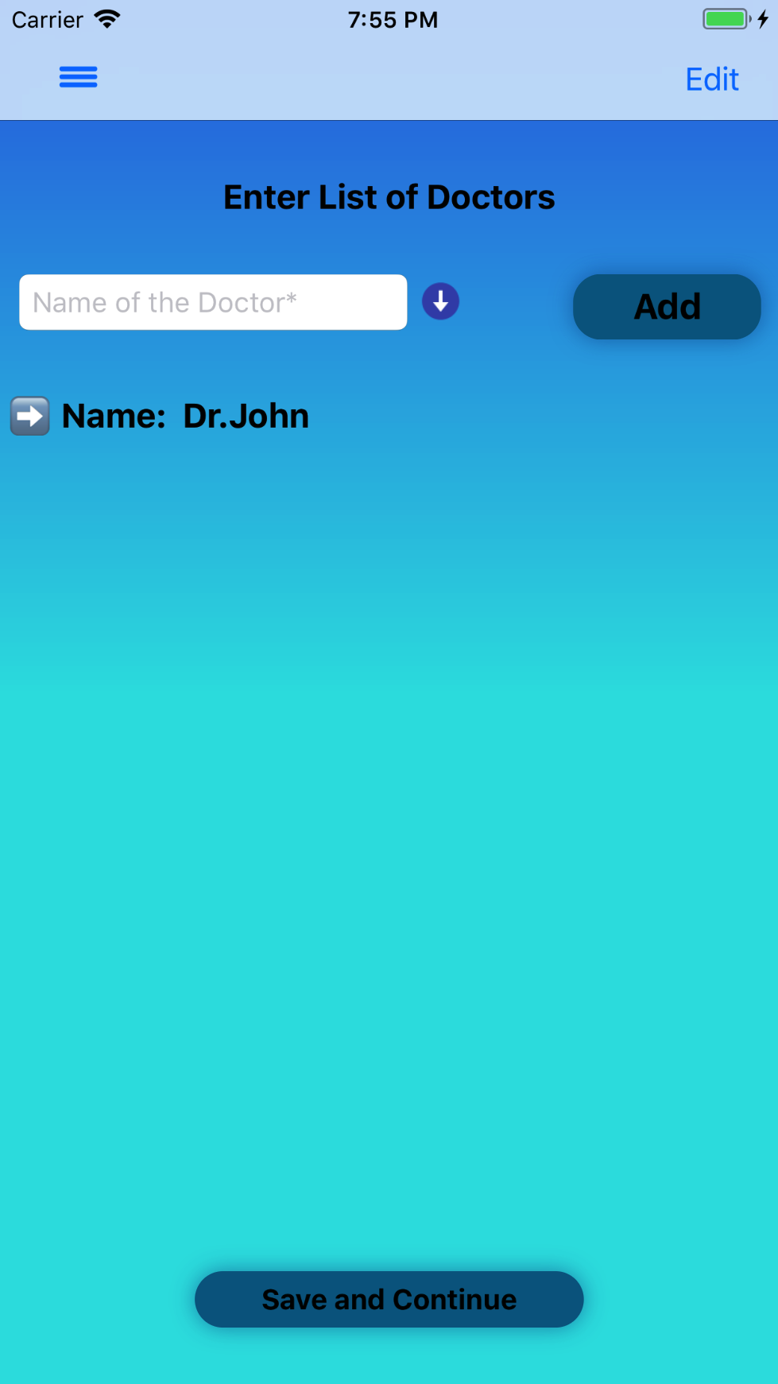

*Figure 18: Edit Doctor Info Figure 19: Updated Doctor Info*

### 3. Enter List of Illnesses/Diseases

Tapping on **Submit and Continue** on the **Enter List of Doctors** screen will navigate to the **Enter List of Illnesses/Diseases** screen. Fill out the ‘Disease Name’ text field as shown in *Figure 20* and tap on the **Add** button. This will display and save the information.

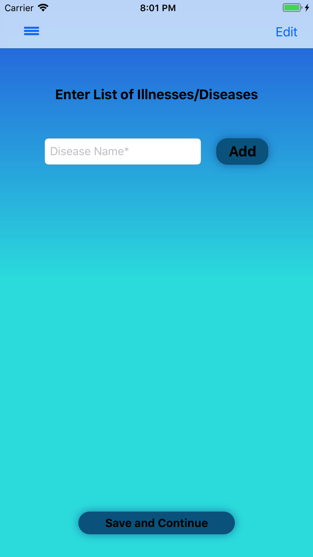

*Figure 20: List of Illnesses/Diseases screen*

### 4. Enter List of Medication

Tapping on **Submit and Continu**e on the **Enter List of Illnesses/Disease** screen will navigate to the **Enter List of Medication** screen. Unlike the **Enter List of Doctors** screen, shown in *Figure 13,* all text fields are displayed when directed to the **Enter List of Medication** screen since all fields are required. Fill out the text fields as shown in *Figure 21* and tap on the **Add** button. This will display and save the information.

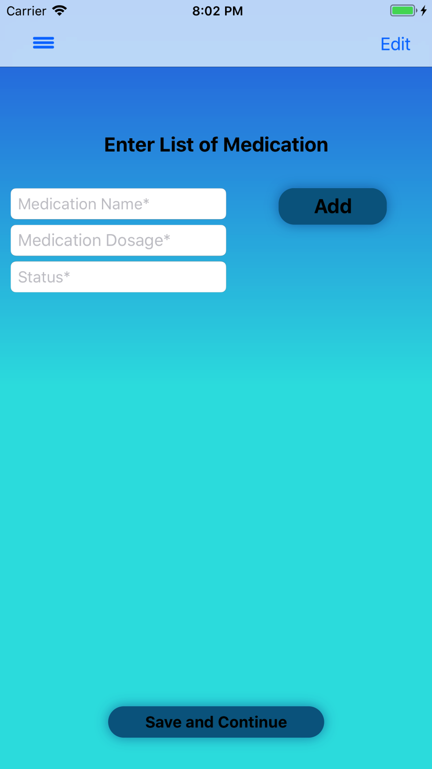

*Figure 21: List of Medication screen*

### 5. Enter List of Surgeries

Tapping on **Submit and Continue** on the **Enter List of Medication** screen will navigate to the **Enter List of Surgeries** screen, *see Figure 22*. Tap on the **blue, drop-down arrow** to expand the optional text fields. Fill out the text fields and tap on the **Add** button. This will display and save the information.

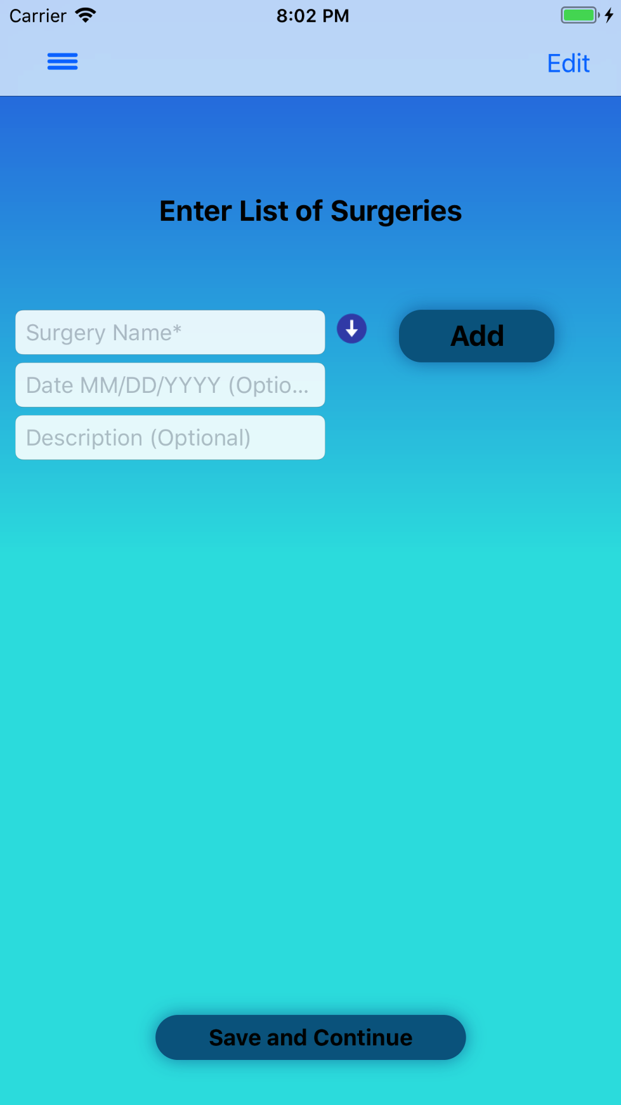

*Figure 22: List of Surgeries screen*

### 6. Enter List of Allergies

Tapping on **Submit and Continue** on the **Enter List of Surgeries** screen will navigate to the **Enter List of Allergies** screen, *see Figure 23*. Tap on the **blue, drop-down arrow** to expand the optional text fields. Fill out the text fields and tap on the **Add** button. This will display and save the information.

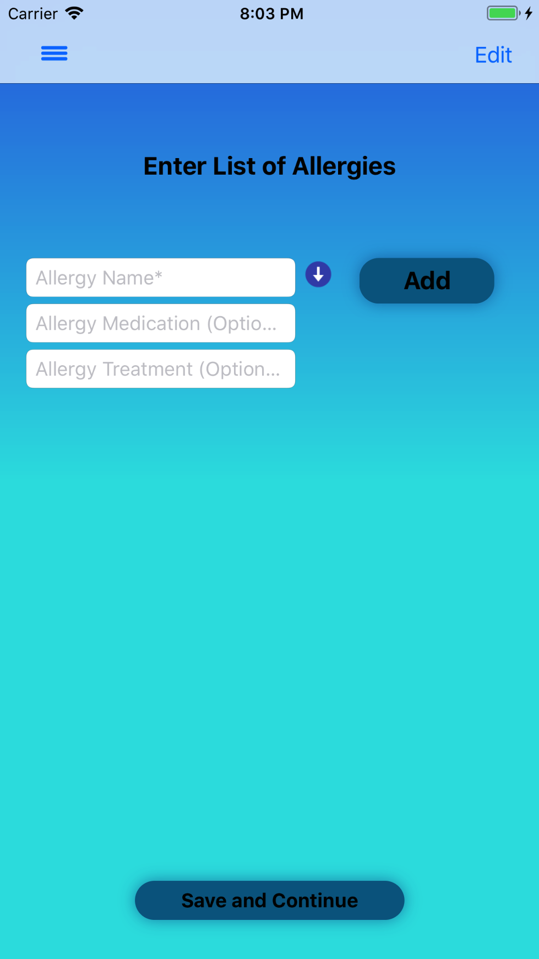

*Figure: 23 List of Allergies screen*

### 7. Enter List of Vaccines

Tapping on **Submit and Continue** on the **Enter List of Allergies** screen will navigate to the **Enter List of Vaccines** screen, *see Figure 24*. After tapping on the **blue, drop-down arrow** the optional text fields will expand. Fill out the text fields and tap on the **Add** button. This will display and save the information.

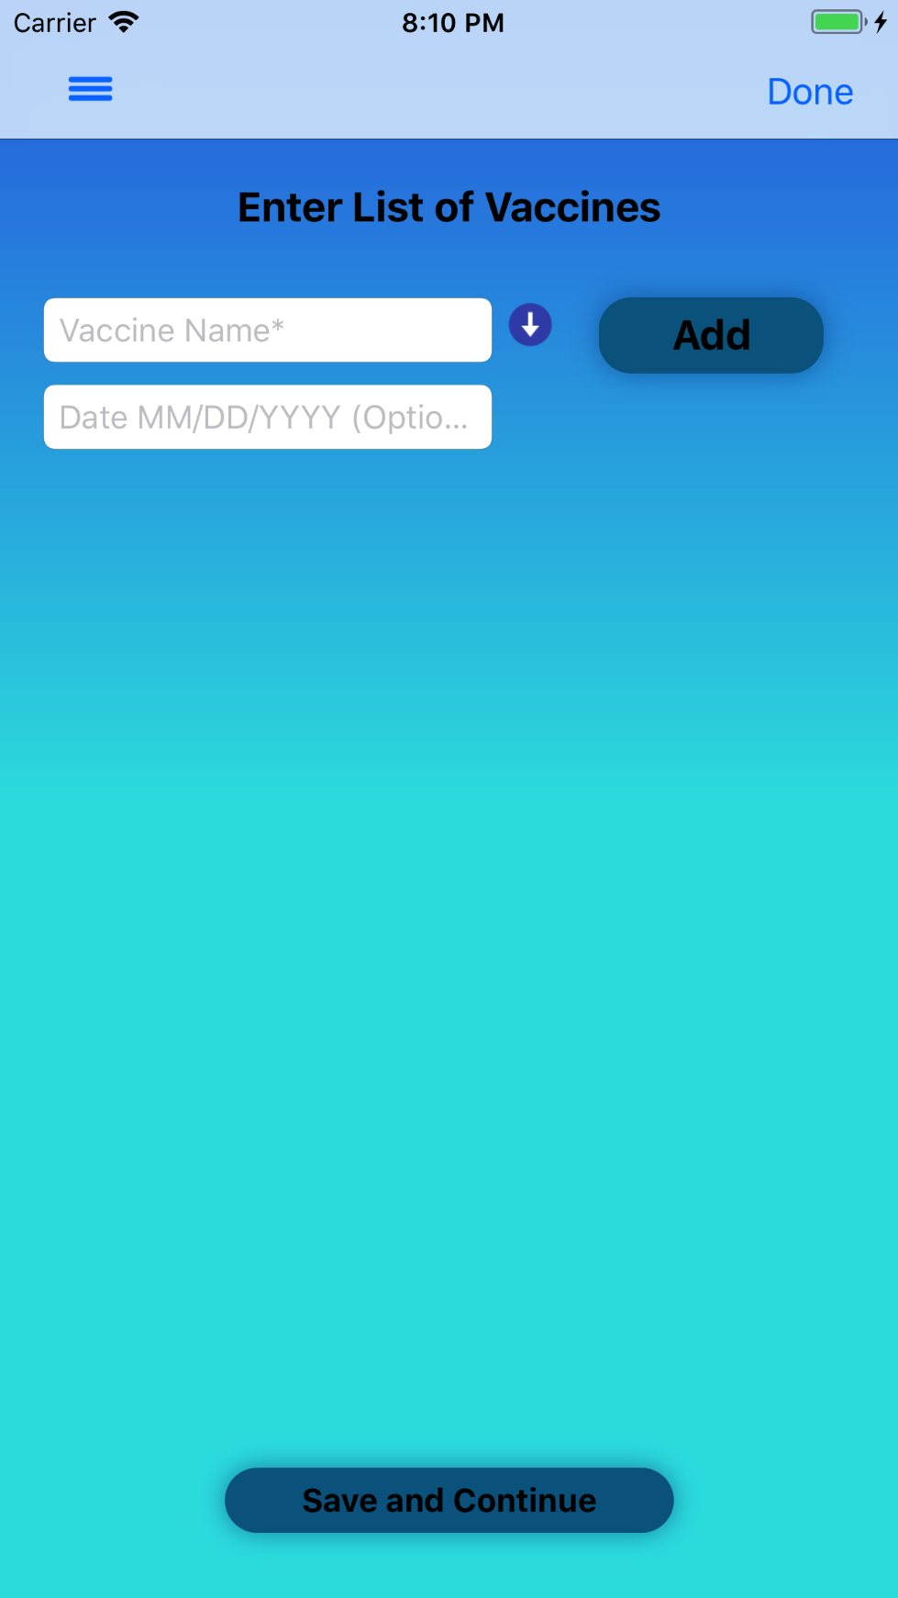

*Figure 24: List of Vaccines screen*

### 8. Medical History

Tapping on **Submit and Continue** on the **Enter List of Vaccines** screen will navigate to the **Medical History** screen, as shown *in Figure 25*. After entering in information in the Family Medical History and Additional Note text boxes, save the data by tapping on the **Save and Continue** button.

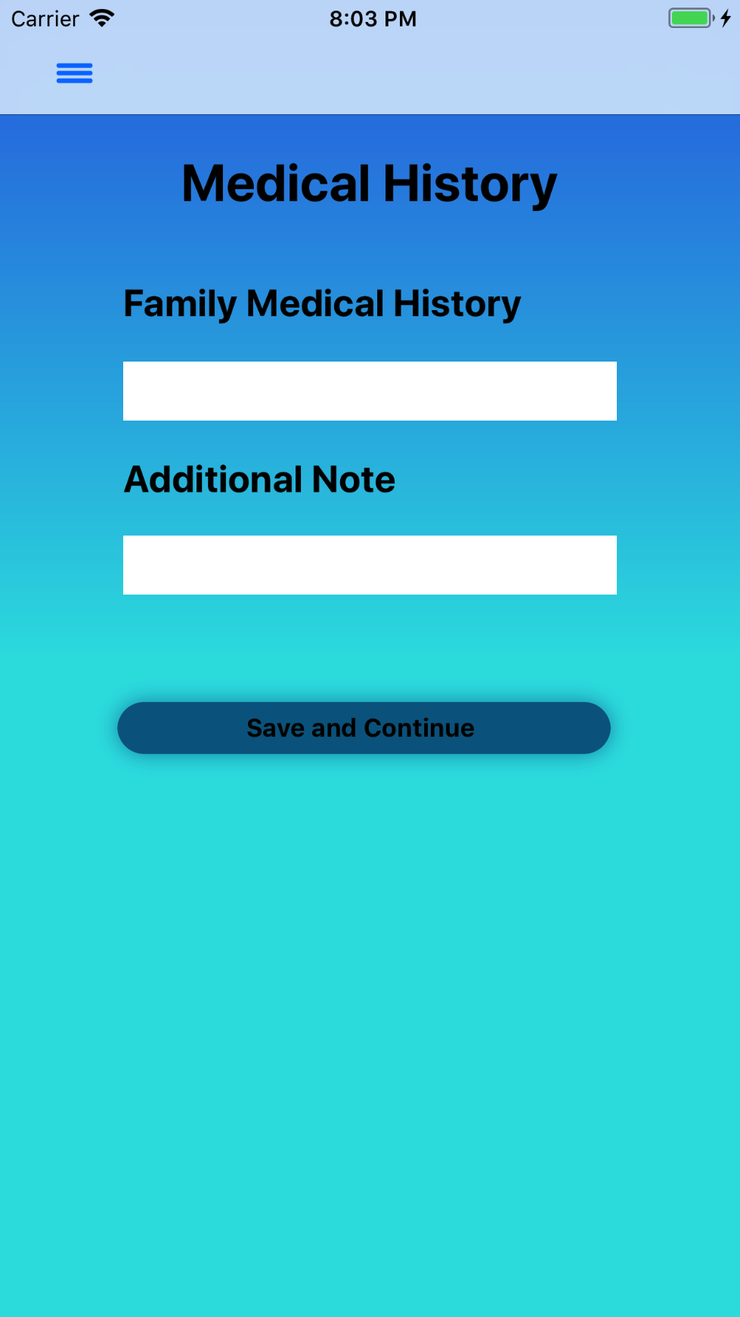

*Figure 25: Family Medical History*

### 9. Insurance Information

Tapping on **Submit and Continue** on the **Medical History** screen will navigate to the **Insurance Information** screen, *see Figure 26*. After filling out the text fields save the information by tapping on the **Save and Finish** button. After the information is saved, a popup will appear asking to upload a document see *Figure 27*. If ‘Yes’ is selected, the application will open the **Upload Document** screen. If ‘No’ is selected, the popup will disappear.

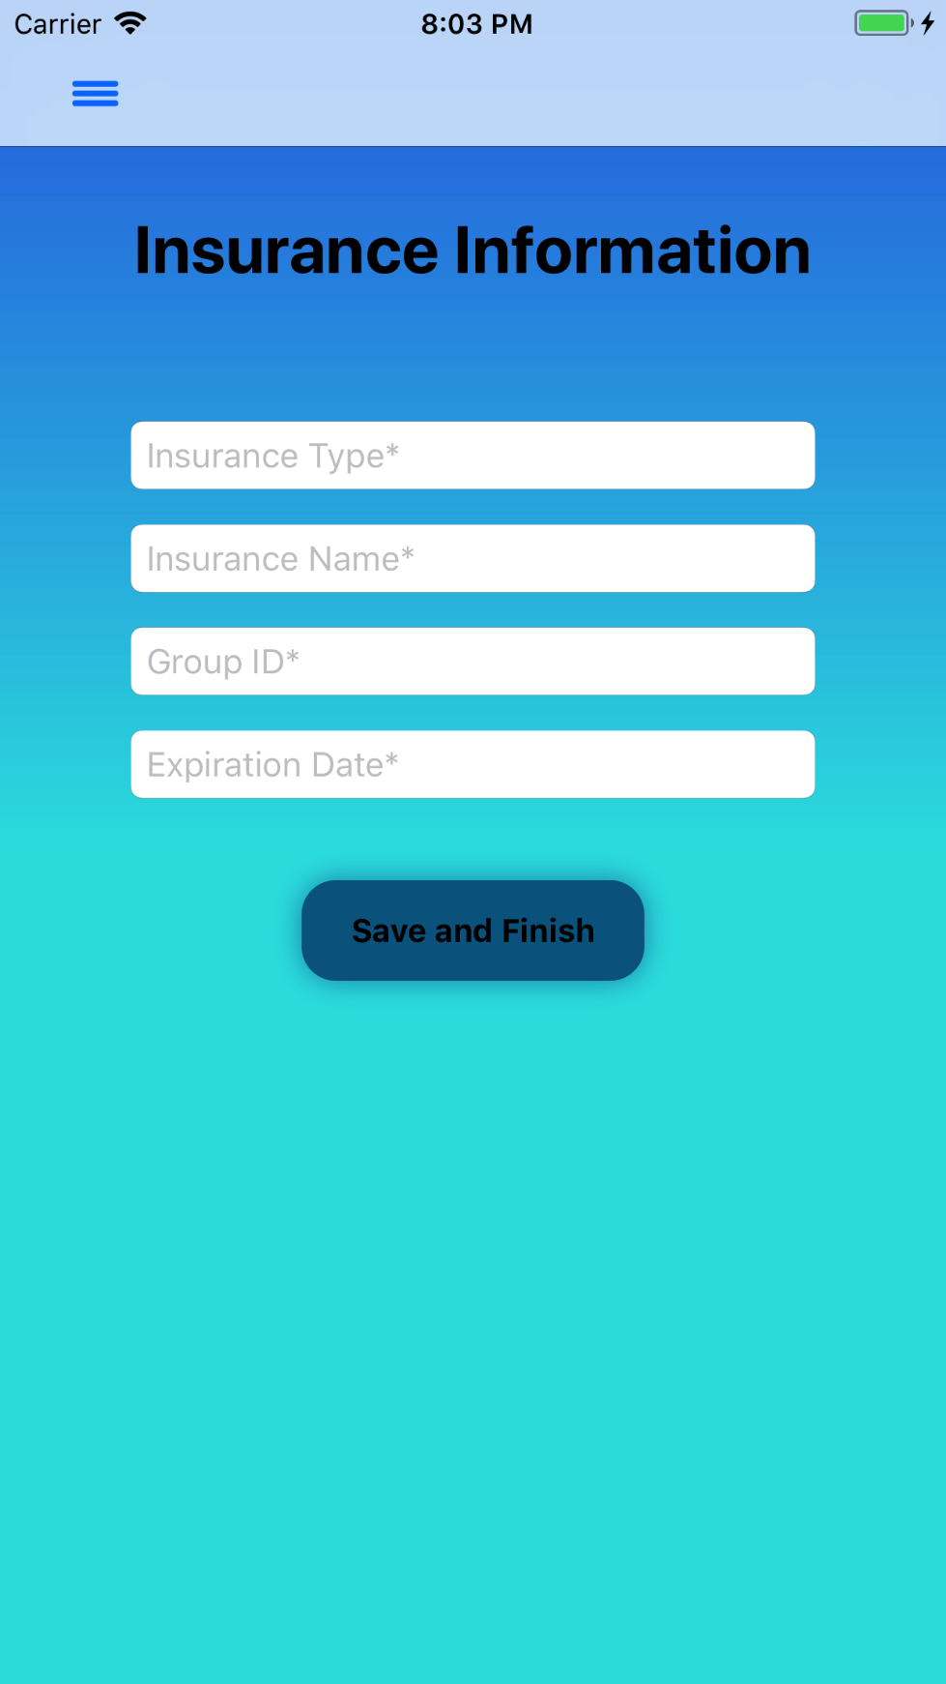 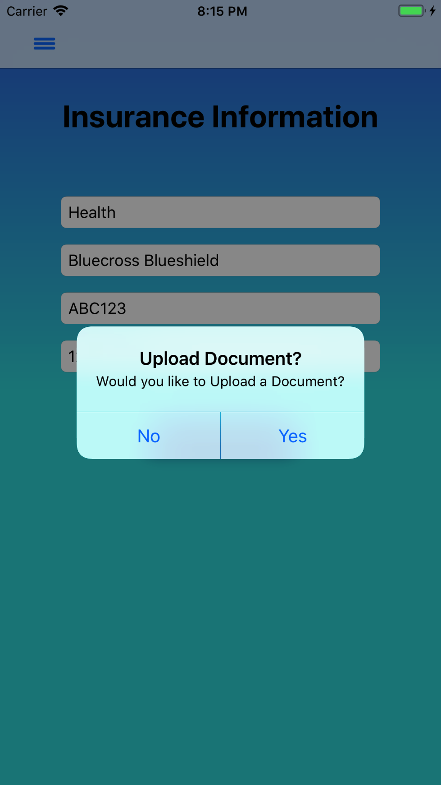

*Figure 26: Insurance Info Figure 27: Upload Document Alert*

### 10. Medical Summary

Tapping on **Save and Finish** on the **Medical History** screen will navigate to the **Medical Summary** screen, *see Figure 28*. This screen displays the Medical Information that has been entered on the Medical pages.

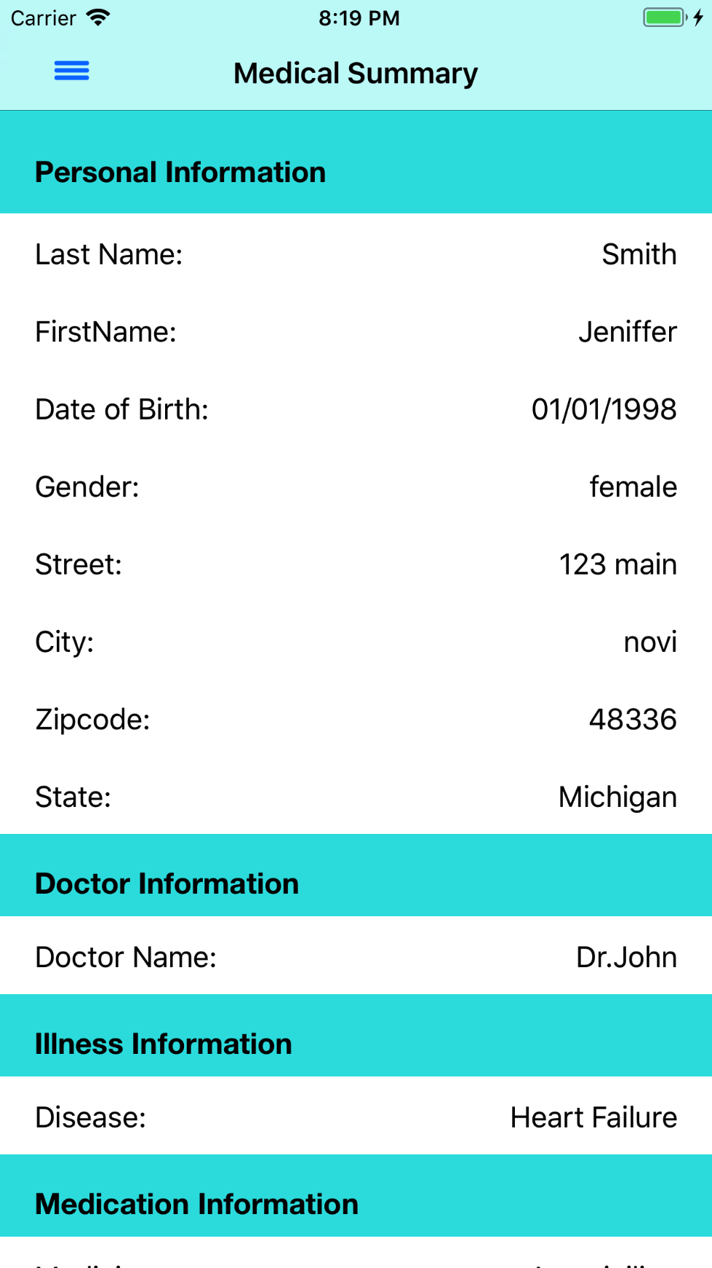

*Figure 28 Medical Summary*

## Upload Document

A document can be uploaded by tapping **Upload Document** from the **Main (Home)** screen, see *Figure 8.* A document can be uploaded by either using the Camera or Photo Library, see *Figure 29*. After selecting an image, tap **Save** located on the bottom right corner of the screen. Enter the Document Name (required) and Document Description (optional). Tap **OK** when finished, see *Figure 30.*

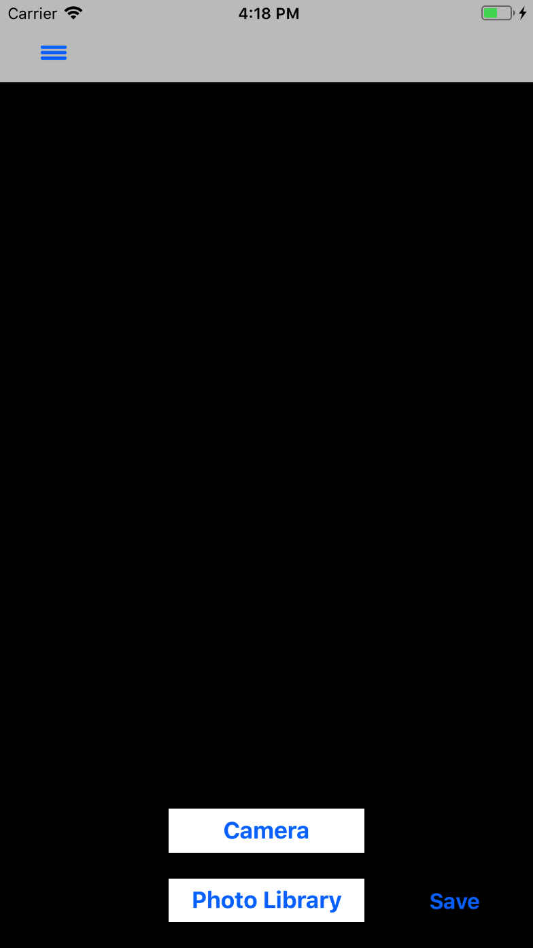 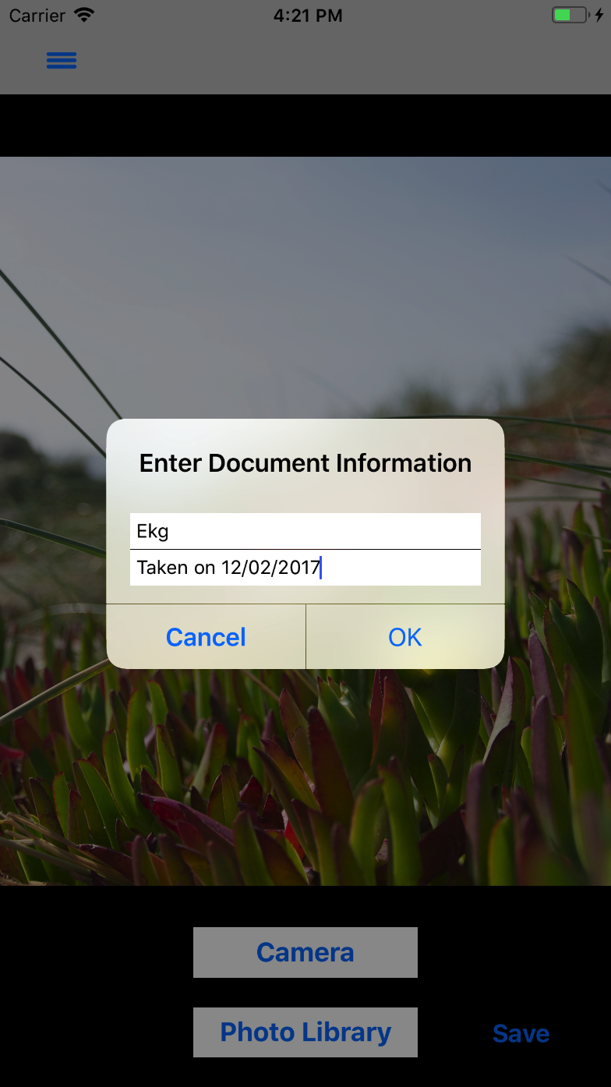

*Figure 29: Upload Document screen Figure 30: Save Document Information*

After tapping **OK** on the **Upload Document** screen, the **Uploaded Documents** screen appears with uploaded images as shown in *Figure 31.* Tap the **Finish** button when done uploading documents, and an alert will appear asking to Set a Reminder as shown in *Figure 32.*

 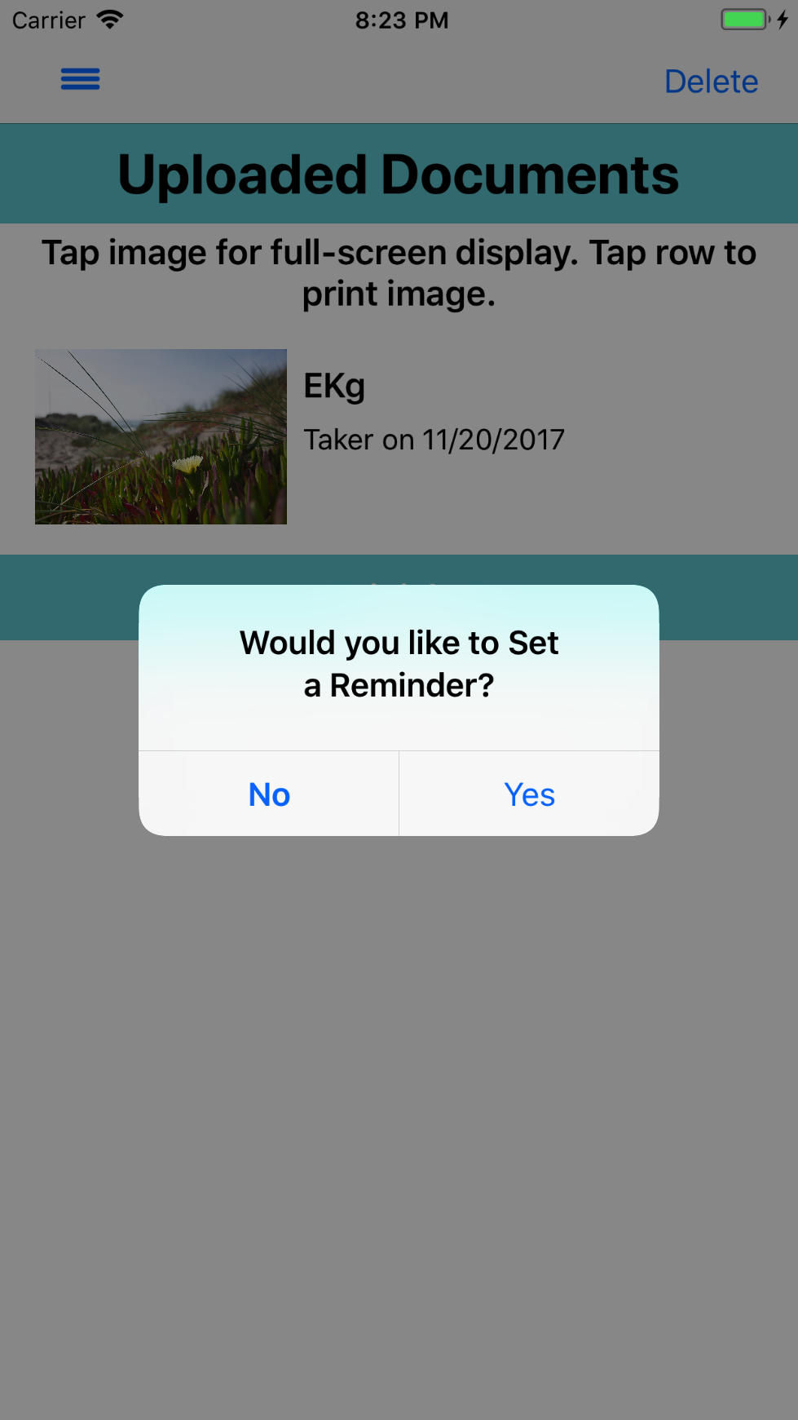

*Figure:31 Uploaded Documents Figure:32 Set Reminder Alert*

## Set Reminder

If ‘Yes’ is selected in the alert in *Figure 32*, MyHealthKeeper will open the **Add Reminder** screen. If it is the first time the screen has been opened, an alert will appear asking for permission for MyHealthKeeper to send notifications to the iOS device, shown in *Figure 33.* If ‘Yes’ is selected in the alert in *Figure 33*, MyHealthKeeper will be granted permission to send notifications to the iOS device. If ‘No’ is selected, the application will not send notifications to the iOS device. This preference can be changed at any time by adjusting MyHealthKeeper’s Application Settings in the device’s Settings.

To add an Appointment Reminder, enter a Name in the ‘Reminder Name’ field and select a Date for the reminder notification to be sent using the picker. Enter a ‘Reminder Location’ and a ‘Reminder Reason’ (optional). After adding the Reminder Information into the fields, save the Reminder by tapping the **Submit and Continue** button.

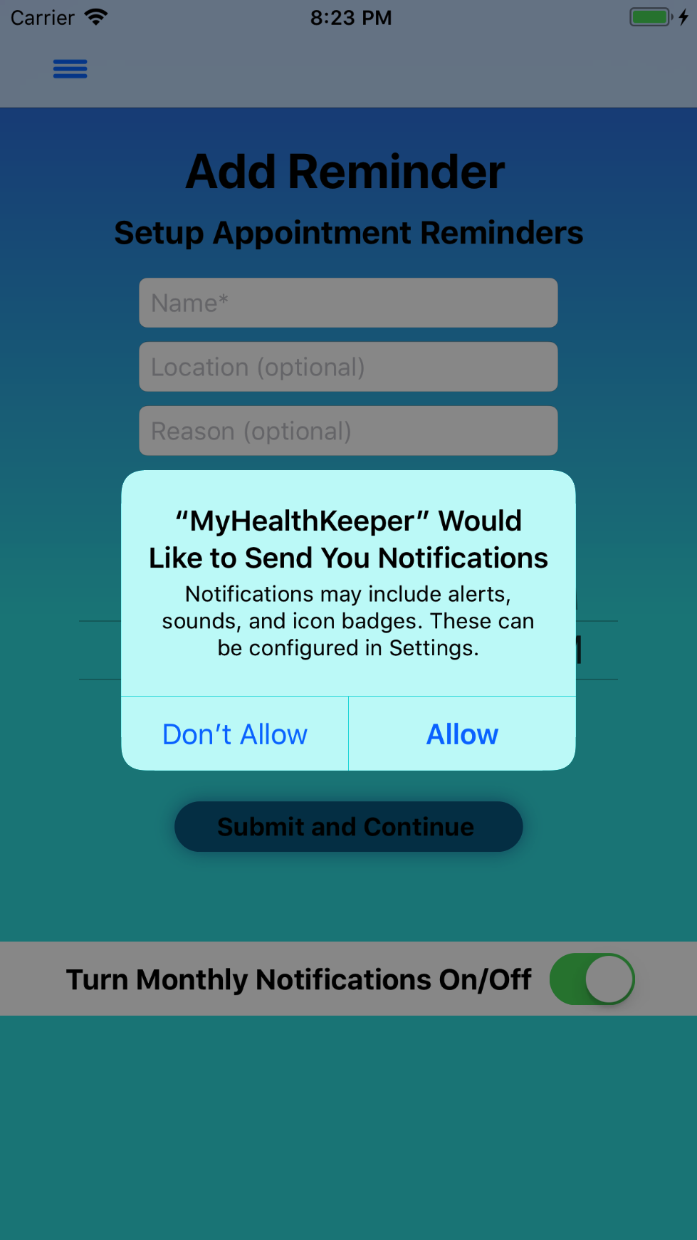 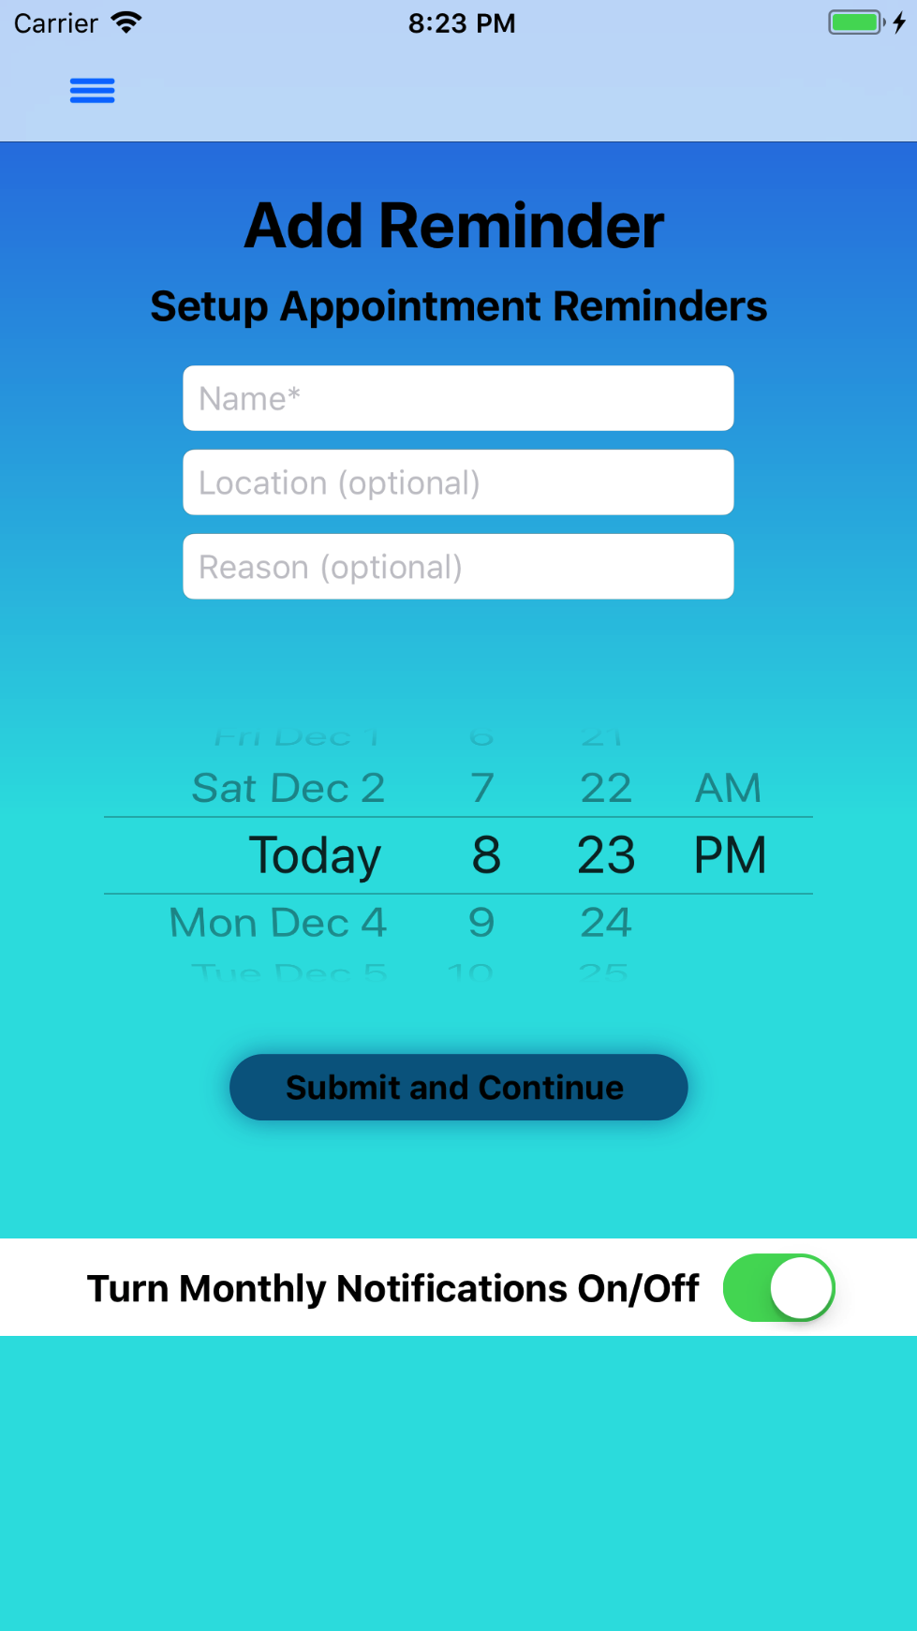

*Figure 33: Monthly Reminder Figure 34: Add Reminder*

## View Reminders

After the saving a Reminder, the ‘View Reminder’ screen will appear, shown in *Figure 35.* This screen will display all of the Reminders that have been entered and saved.



*Figure 35: View Reminders*

## Print

By tapping on the **Print** button on the **Menu**, the application will navigate to the **Print Report** screen to print a report of the Medical Summary. When the application navigates to that screen, an alert will appear asking to upload an image to include in the report, shown in *Figure 36.*

If ‘Yes’ is selected, the application will navigate to the **Uploaded Documents** screen to select an image by tapping on the row of the displayed image.An alert will appear on the screen to confirm the image selection. If ‘Yes’ is selected, the alert will disappear from the screen, and the app will navigate back to the **Print Report** screen where the selected image will be displayed on the center of the screen shown in *Figure 37.* There are two buttons for the type of report to print: one for a Standard Report and one for a Detailed Report. A preview of each report can be viewed on the **Printer Options** screen when either button is tapped.

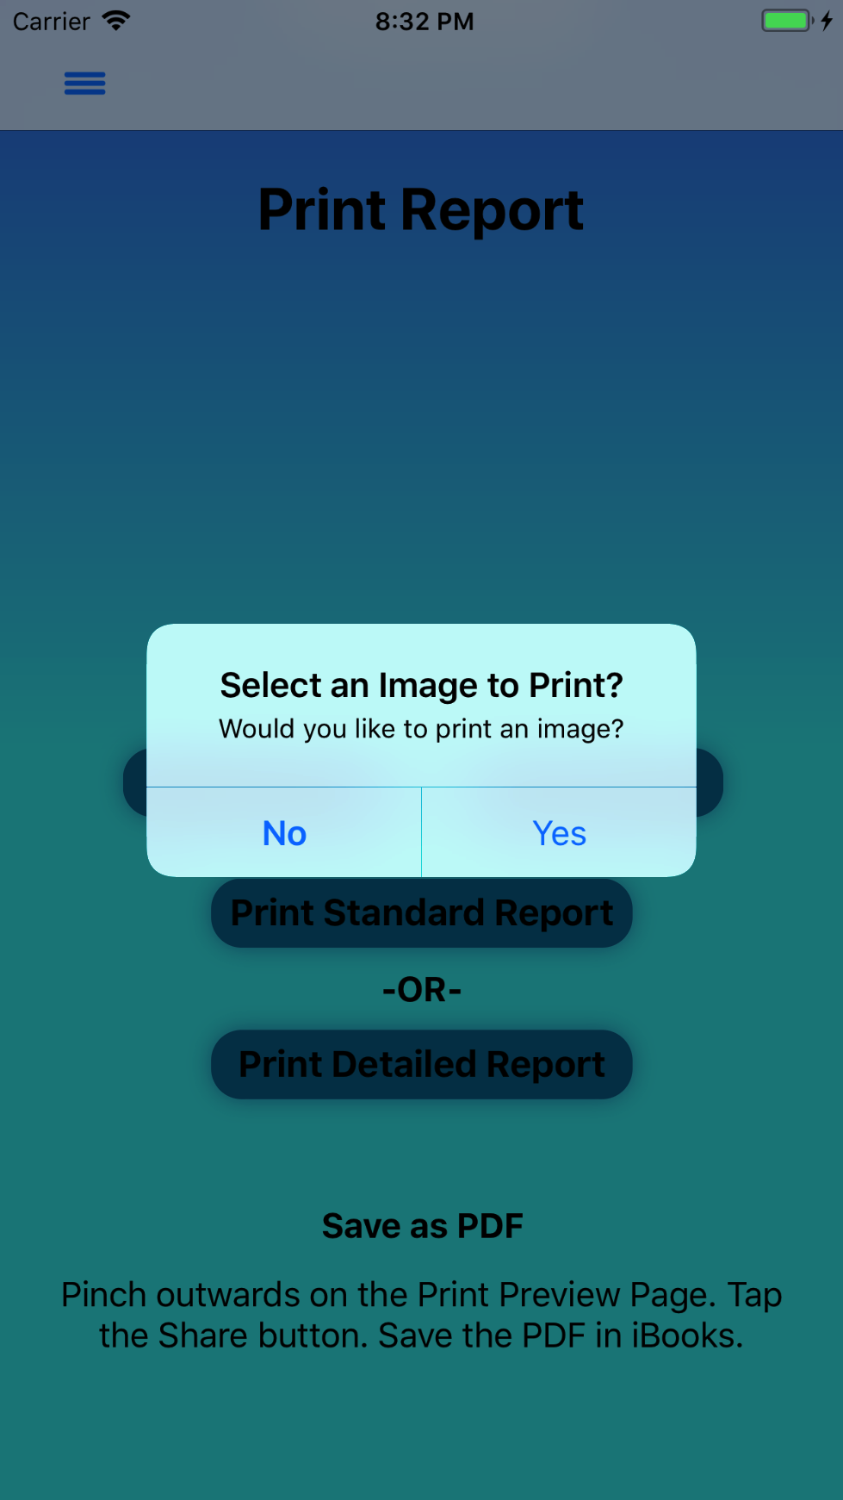 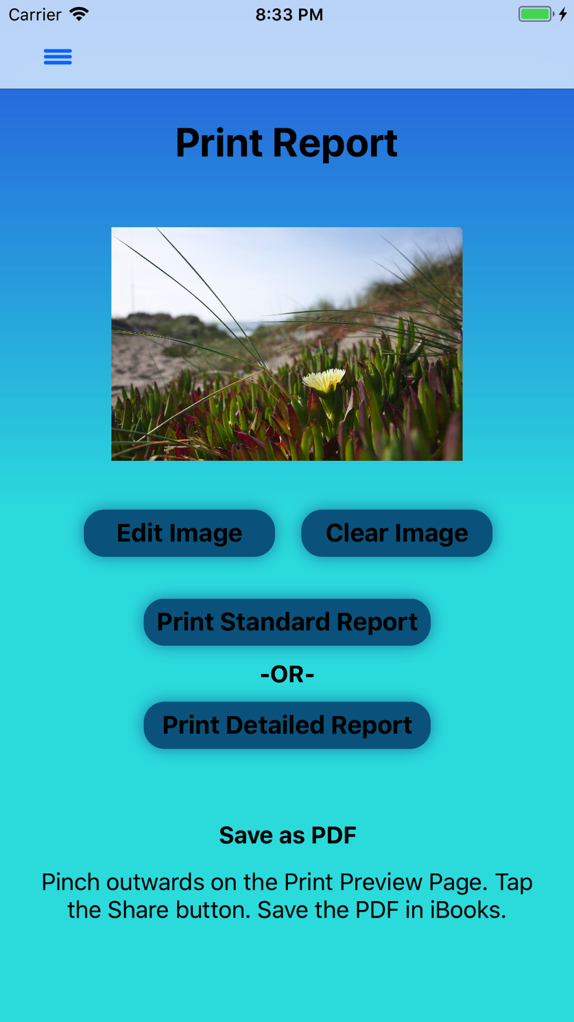

*Figure 36: Print Report screen Figure 37: Print Report with selected image*

If ‘No’ is selected from the alert that was shown in *Figure 36*. The **Print Report** screen will be displayed without an image as shown in *Figure 38.* A Detailed Report with an image is shown in *Figure 39.*

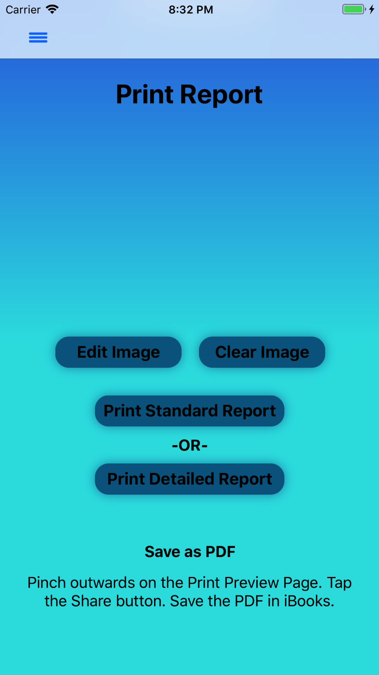 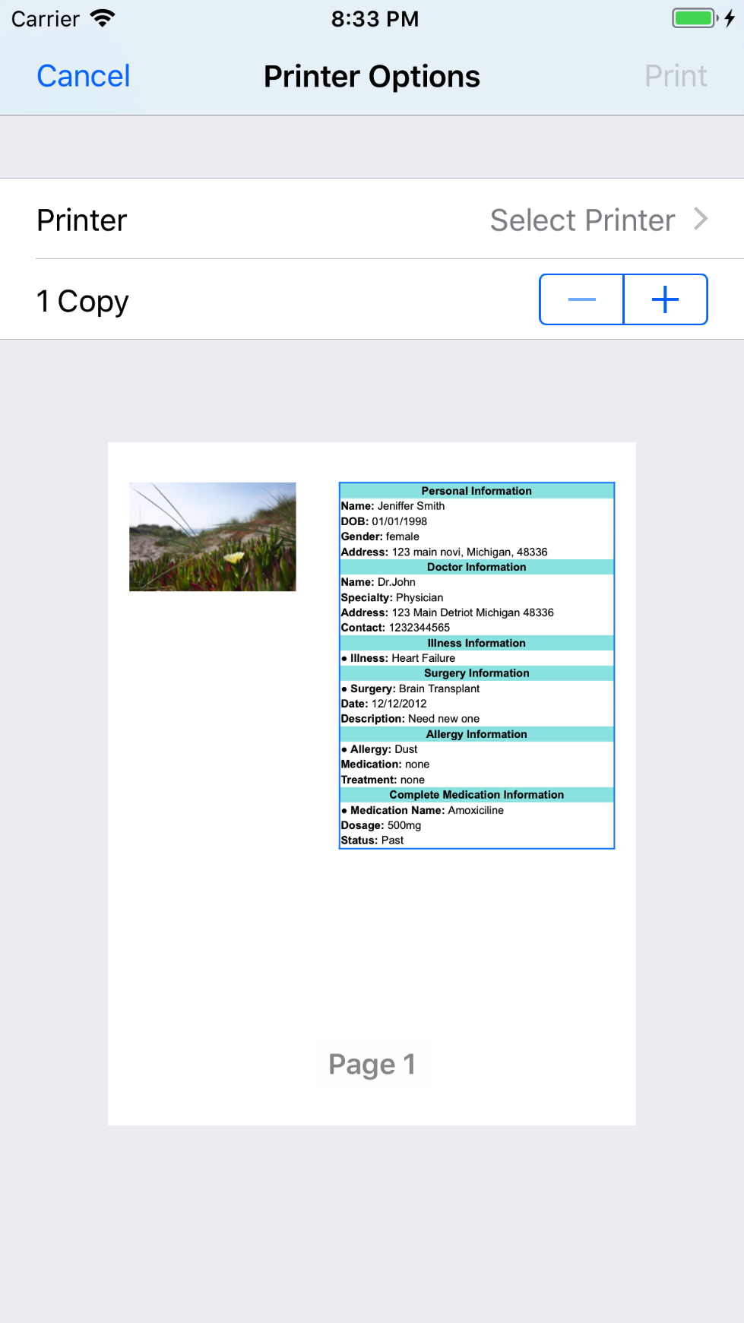

*Figure 38: Print Report without image Figure 39: Detailed Report with image*

By swiping or using 3D touch on the Printer Options screen, shown in *Figure 39,* the report can be exported and saved as a PDF in iBooks, see *Figure 40*.

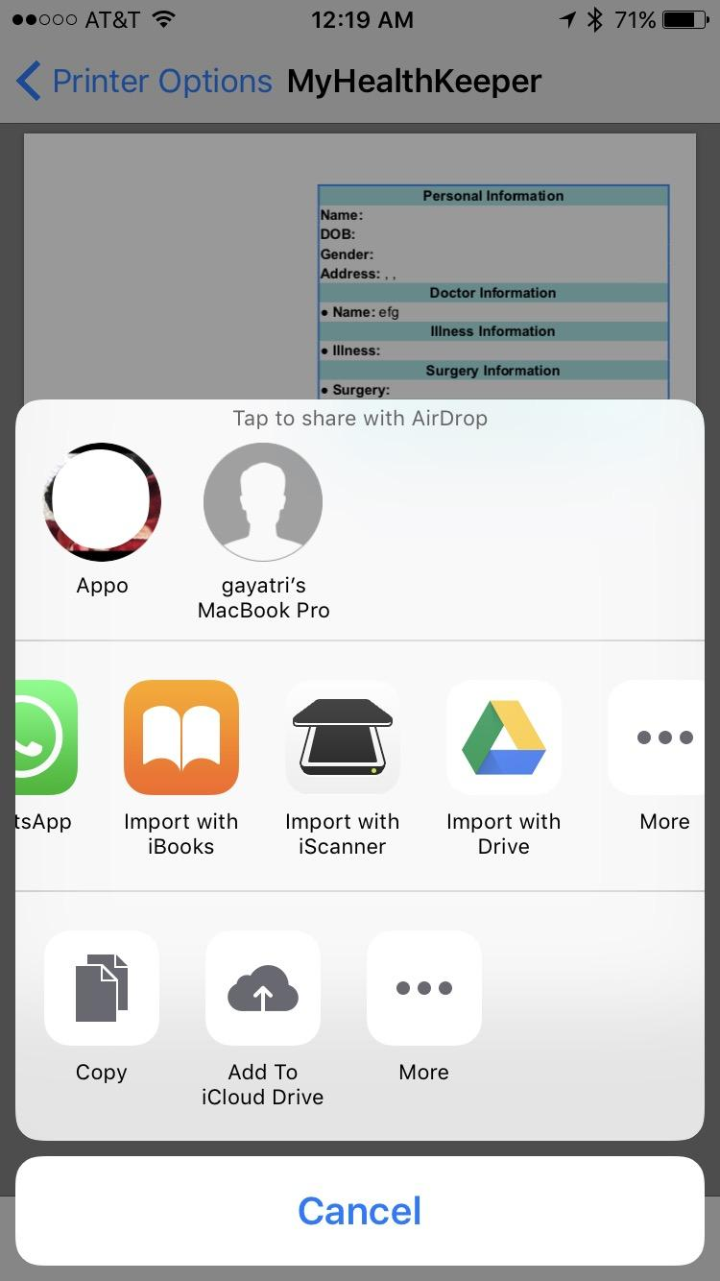

*Figure 40: Save Report as PDF*